REPLACE THE WORD "HELLO" WITH "HI" USING LEX

Aim
To write and implement a LEX program to replace every occurrence of the word "hello" with "hi" in the given input text.

Algorithm
1. Start the program.
2. Define a LEX rule to recognize the word hello.
3. Replace each matched occurrence of hello with hi.
4. Print all other characters without modification.
5. Read the input text and process it using yylex().
6. Stop the program.

Pseudocode
BEGIN
SCAN input using LEX
IF "hello" is matched, PRINT "hi"
ELSE, PRINT the original character
END IF
END
Program (replace.l)
%{
#include <stdio.h>
%}
%%
hello { printf("hi"); }
.|\n { ECHO; }
%%
int main(void)
{
yylex();
return 0;
}
int yywrap(void)
{
return 1;
}

Sample Input
hello everyone
welcome to hello world

Output
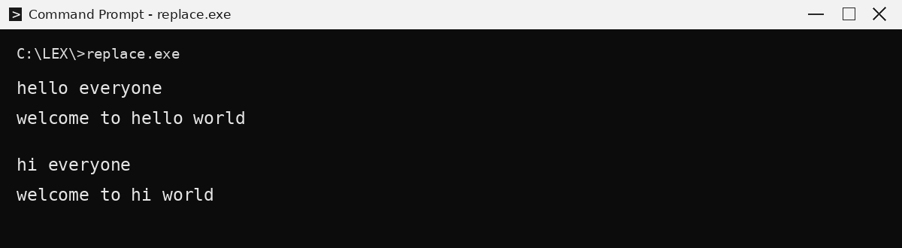

Result
Thus, the LEX program to replace the word "hello" with "hi" in the given input text was implemented successfully.

